INDEX

PURPOSE 1
FIRST LEVEL TITLE 1
SECOND LEVEL TITLE 1

PURPOSE
The document aims to provide a step-by-step guide on how to use 7-Zip, a popular file compression and encryption tool, to encrypt one or more files. It is intended to help users protect their sensitive data by encrypting files before sharing or storing them.

CONTEXT

7-Zip is an open-source file archiver with a high compression ratio, widely used for compressing and encrypting files. The document likely includes:
- Introduction to 7-Zip: An overview of 7-Zip, its features, and its benefits for file compression and encryption.
- Installation Instructions: Steps to download and install 7-Zip on a Windows system.
- Encrypting Files: Detailed instructions on how to use 7-Zip to encrypt files, including:
  - Selecting files for encryption.
  - Setting a strong password.
  - Choosing the encryption method (e.g., AES-256).
- Creating Encrypted Archives: How to create encrypted archive files (e.g., .7z or .zip) that can be securely shared or stored.
- Best Practices: Tips for ensuring strong encryption, such as using complex passwords and securely managing encryption keys.
This document is intended to be a practical guide for users who need to secure their files using 7-Zip, providing clear and concise instructions to ensure effective encryption.

Steps
Select the group of files and/or folders (one or more) that you want to encrypt, do a right click mouse over the selection, select the application “7-Zip” and finally select “Add to archive …”
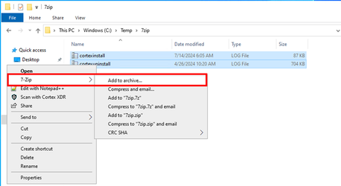
Step 2
Once 7zip window appears, do the following:
- Select the format “.zip”, because other formats could give problems during the decryption.
- Introduce a secure password, which will be used to protect the file generated.
- Select the encryption method “AES256”
- Press “OK”: and a new single file will be generated with the extension “.zip”.

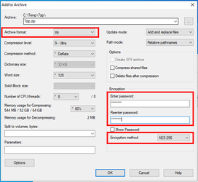
Step 3
Verification: if you open the new “.zip” file, the content will be shown. But if you try to decompress the zip file, or you try to directly open a file inside the compressed pack, you will be asked for the password.

